Health Screening
1. Have you experienced ANY of the following symptoms within the past 10 days: (a) a fever of 100.4◦ F or greater; (b) a new cough; (c) new loss of taste or smell; OR (d) shortness of breath?
□ No. Go to the next question.
□ Yes. STOP HERE. No further screening is needed. Visitor may not be admitted. An employee may not report to work pending clearance from HR.

2. In the past 10 days, have you tested positive for COVID-19, either using a test that used a nose or throat swab, or tested saliva (i.e., not a blood test)? Measure 10 days from the day of the test, not from the day you got the test result.
□ No. Go to the next question.
□ Yes. STOP HERE. No further screening is needed. Visitor may not be admitted. An employee may not report to work pending clearance from HR.

3. To the best of your knowledge, in the past 14 days, have you (a) been in close contact (within 6 feet for at least 10 minutes) with anyone while they had COVID-19 OR (b) traveled internationally or returned from a state identified by New York State as having widespread community transmission of COVID-19 (other than just passing through the restricted state for less than 24 hours)? (For state list, see: https://coronavirus.health.ny.gov/covid-19-travel-advisory.)
□ No. Employee may report to work. Visitor may be admitted.
□ Yes. If the employee/visitor has been deemed an “essential worker” by his or her employer,* go to the next question. Otherwise, STOP HERE. No further screening is needed: visitor may not be admitted; employee may not report to work pending clearance from HR.

4. A) Are you a law enforcement officer or other first responder who has been deemed an essential worker for your agency?
□ No. STOP HERE. Visitor may not be admitted; employee may not report to work pending clearance from HR.
□ Yes. 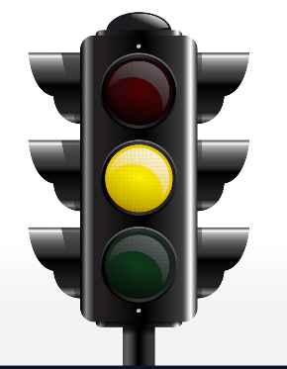 Go to next page, to Question 4B).

****THIS ENTIRE PAGE IS ONLY FOR ESSENTIAL WORKERS* WHO GOT A YELLOW LIGHT OUTCOME ON THE PRIOR PAGE.****

4. B) Are both of the following true? (1) You have been exposed to COVID-19 in the last 14 days (either by close contact or travel) AND (2) after such COVID-19 exposure (by close contact or travel), your employer’s human resources department has confirmed, in writing, that your physical presence in the workplace is critical to the operations or safety of the workplace, despite your exposure to COVID-19?
□ No. STOP HERE. No further screening is needed. The employee may not report to work. Visitor may not be admitted.
□ Yes. Go to the next question.

5. Has your employer provided you with requirements for returning to work after this exposure (your close contact or travel)?
□ No. STOP HERE. No further screening is needed. Individual may not report to work or visit DANY until they receive and affirm they have received these requirements, and agree, in writing, to comply with such requirements.
□ Yes. Go to the next question.

6. Will you comply with the requirements for returning to work provided by your employer?
□ No. STOP HERE. No further screening is needed. The employee or visitor may not report to work/visit DANY.
□ Yes. The employee or visitor may report to work/be admitted to DANY (but not to the rest of 100 Centre).

Please let the officer know if your path through these questions has led to a red stop sign or a green star.

*DANY employees other than police officers and peace officers are not deemed to be essential employees under the Executive Order.

